DATA BASE TASK – 1

**Excersice-1 Task:-**

a) Query: select title from movies;

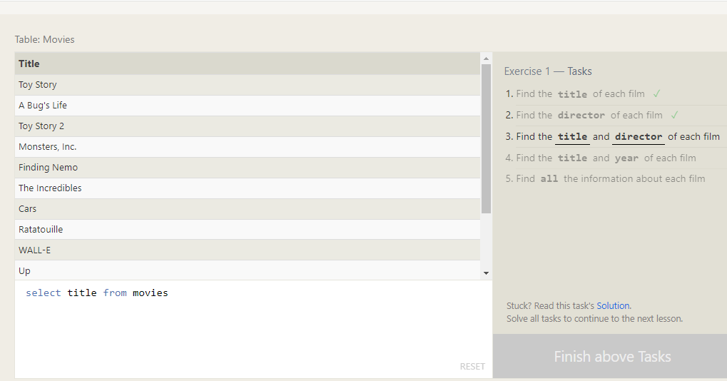

b) Query: select director from movies;

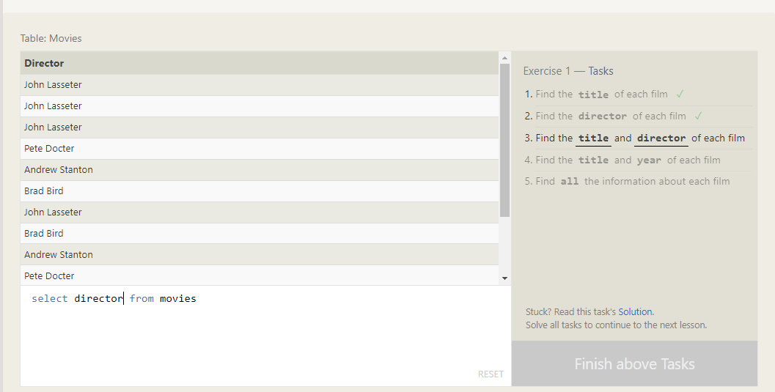

c) Query: select title,director from movies;

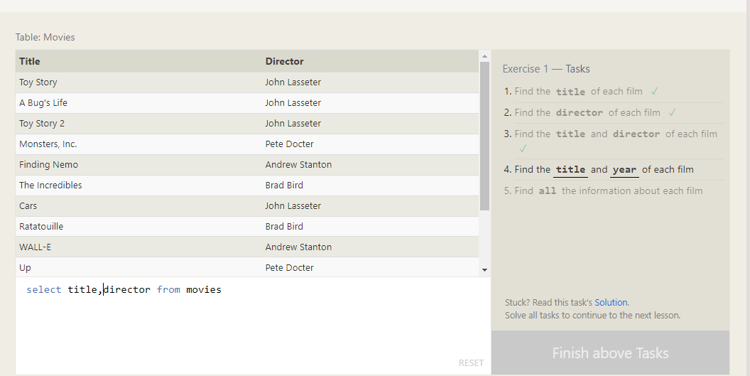

d) Query: select title,year from movies;

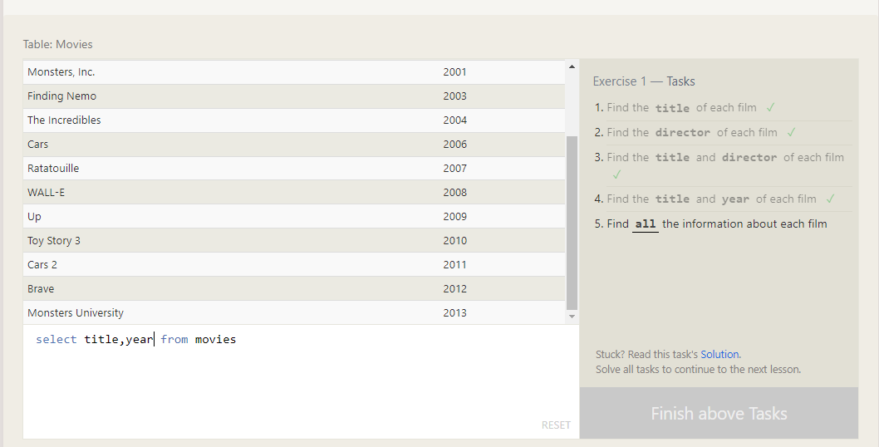

e) Query: select * from movies;

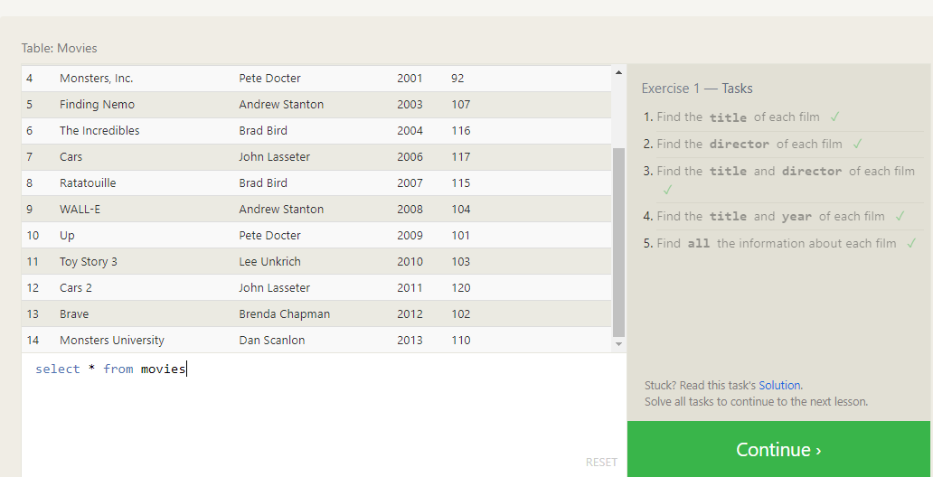

**Excersice-2 Task**

a) Query: select * from movies where id=6;

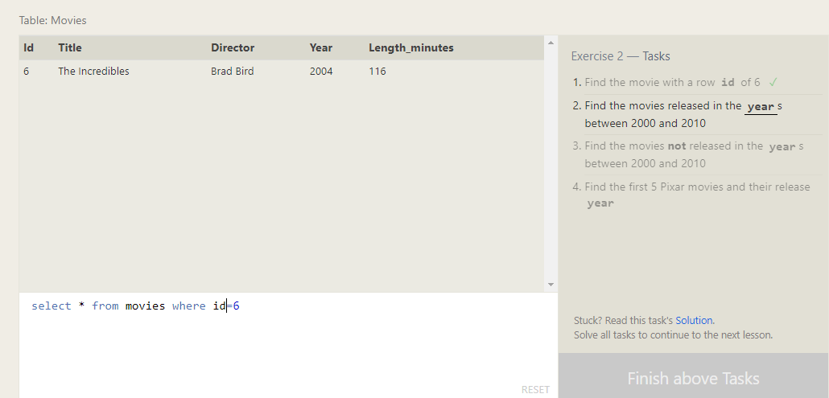

b) Query: select * from movies where between 2000 and 2010;

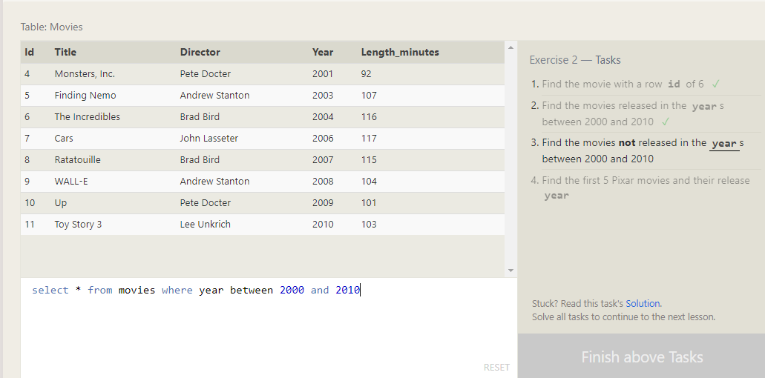

c) Query: select * from movies where year not between 2000 and 2010;

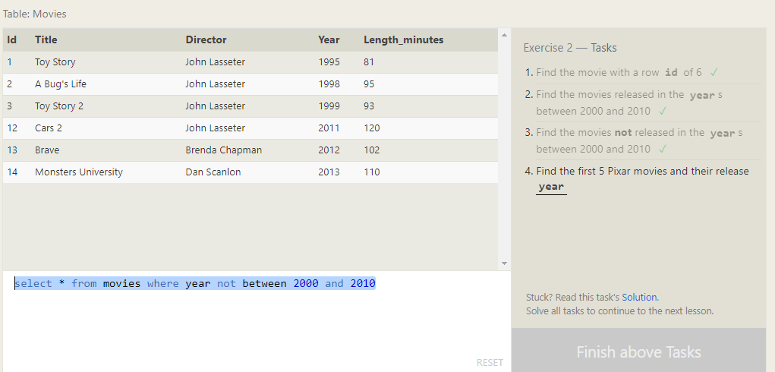

d) Query: select * from movies where id between 1 and 5;

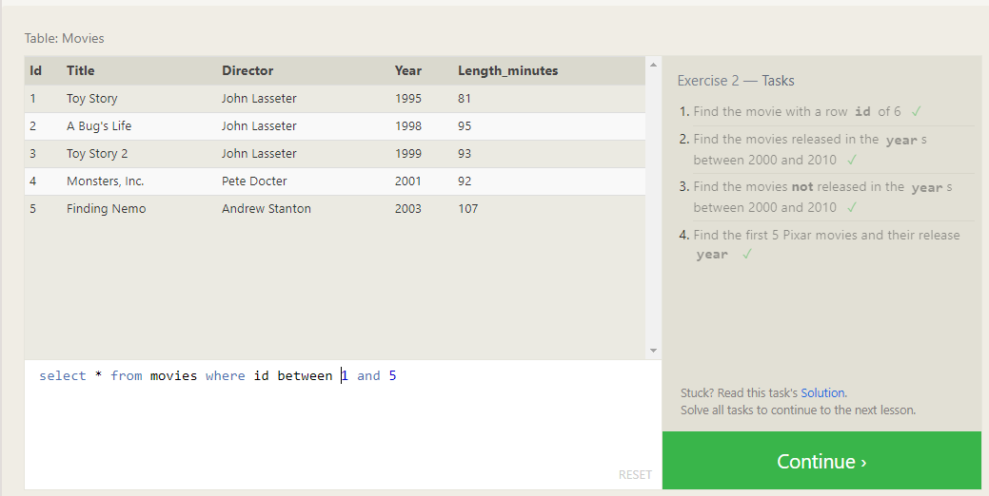

**Excersice-3 Task**

a) Query: SELECT title, director FROM movies

WHERE title LIKE "Toy Story%";

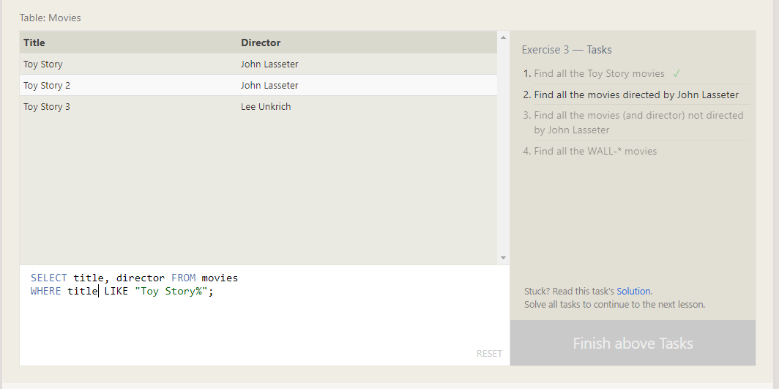

b) Query: select title,director from movies where director like("john lasseter");

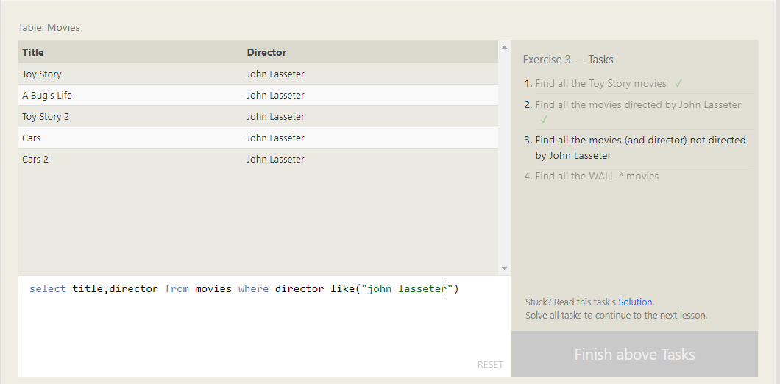

c) Query: select * from movies where director not like "john lasseter";

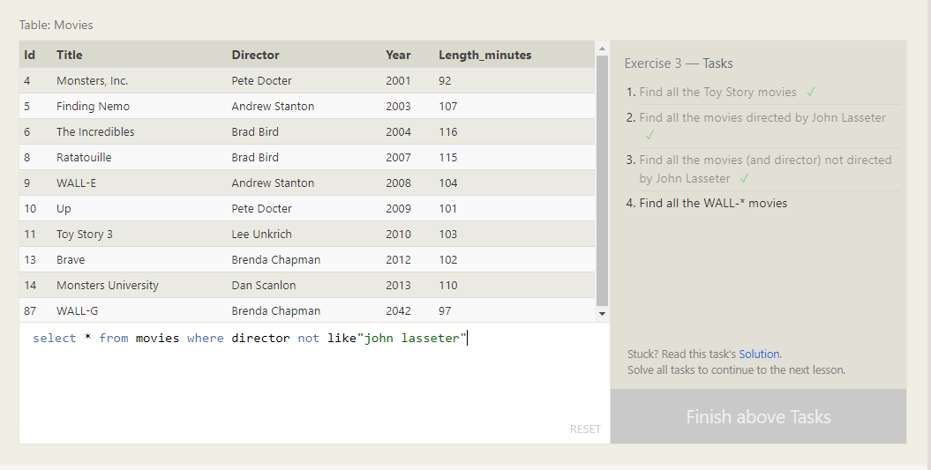

d.) Query: select * from movies where title like("wall-%");

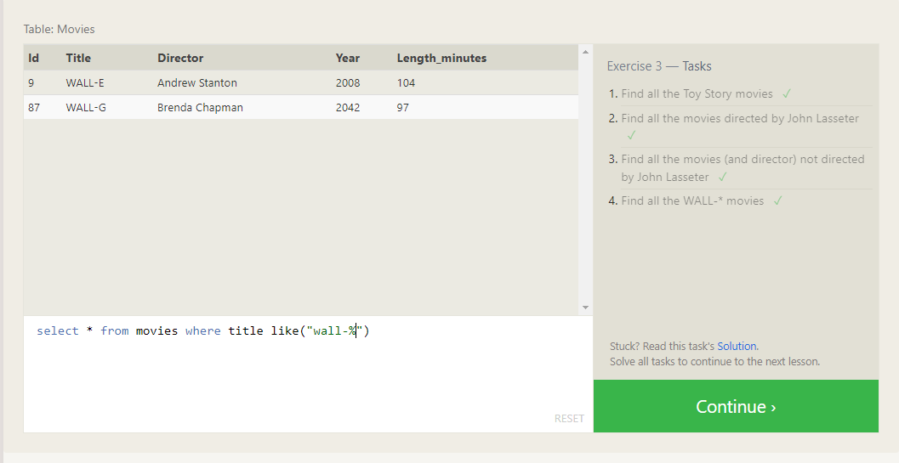

**Excersice-4 Task**

a.) Query: select distinct director from movies order by director;

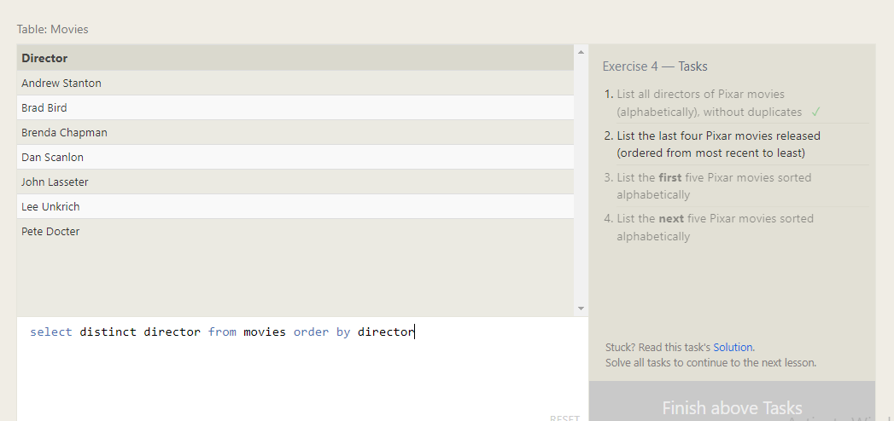

b.) Query: select * from movies where year order by year desc limit 4;

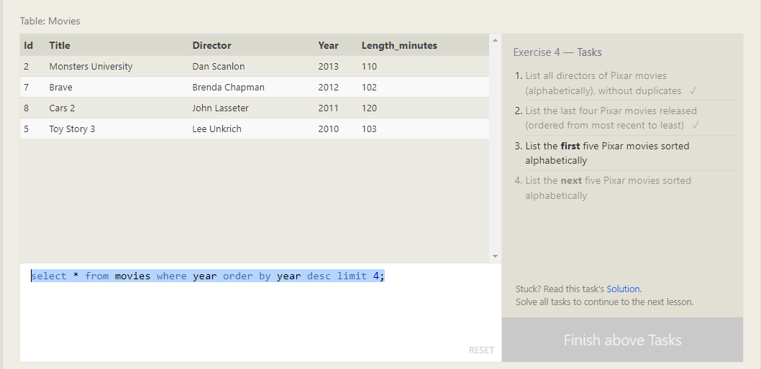

c.) Query: select * from movies group by title limit 5;

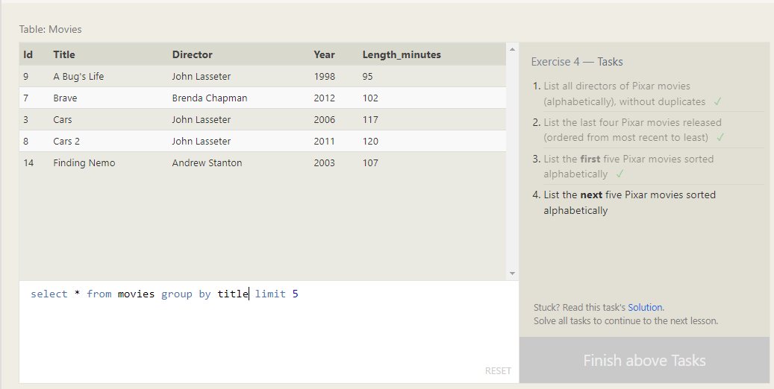

d.) Query : SELECT title FROM movies ORDER BY title ASC LIMIT 5 OFFSET 5;

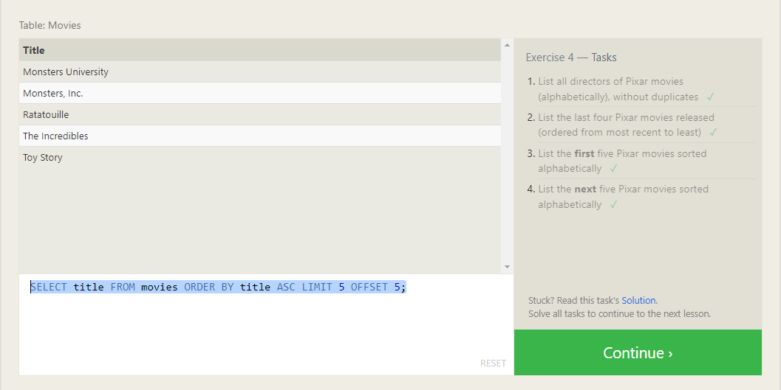

**Excersice-5 Task**

1. select city from north_american_cities where country like("canada");
2. SELECT city, latitude FROM north_american_cities WHERE country = "United States" ORDER BY latitude DESC;
3. SELECT city, longitude FROM north_american_cities WHERE longitude < -87.629798 ORDER BY longitude ASC;
4. select * from north_american_cities where country like("mexico") order by population desc limit 2;
5. select * from north_american_cities where country like("mexico") order by population desc limit 2;

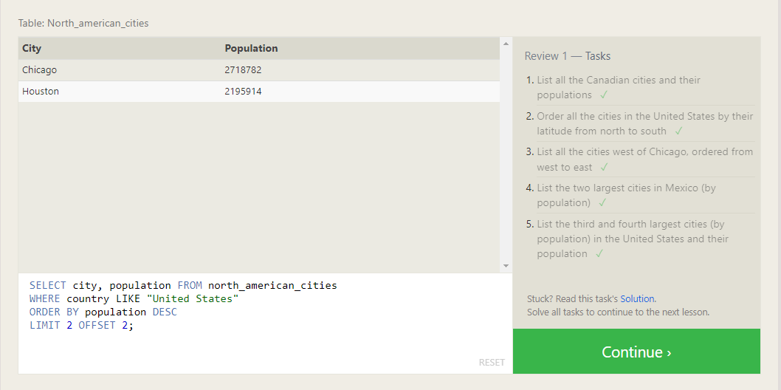

**SQL Lesson 6: Multi-table queries with JOIN**

1. SELECT title, domestic_sales, international_sales FROM movies JOIN boxoffice ON movies.id = boxoffice.movie_id;
2. SELECT title, domestic_sales, international_sales FROM movies JOIN boxoffice ON movies.id = boxoffice.movie_id WHERE international_sales > domestic_sales;
3. SELECT title, domestic_sales, international_sales FROM movies JOIN boxoffice ON movies.id = boxoffice.movie_id WHERE international_sales > domestic_sales;

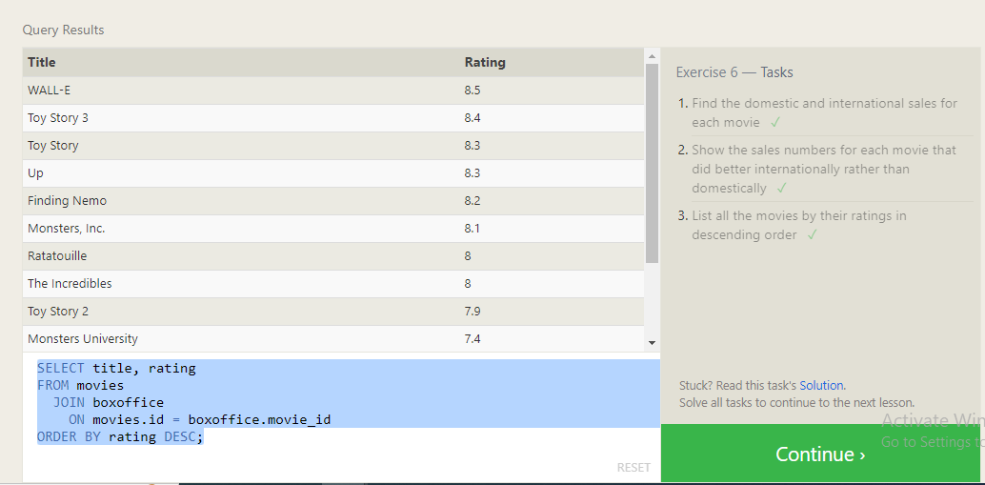

**SQL Lesson 7: OUTER JOIN**

1. SELECT DISTINCT building FROM employees;
2. SELECT * FROM buildings;
3. SELECT DISTINCT building_name, role FROM buildings LEFT JOIN employees ON building_name = building;

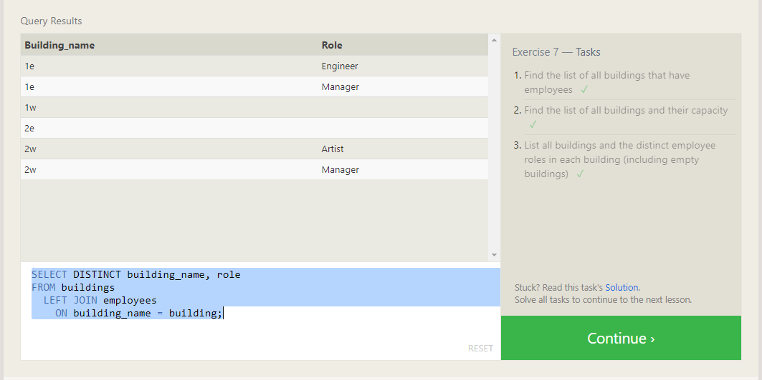

**SQL Lesson 8: A short note on NULL**

1. SELECT name, role FROM employees WHERE building IS NULL;
2. SELECT DISTINCT building_name;
3. FROM buildings LEFT JOIN employees ON building_name = building WHERE role IS NULL;

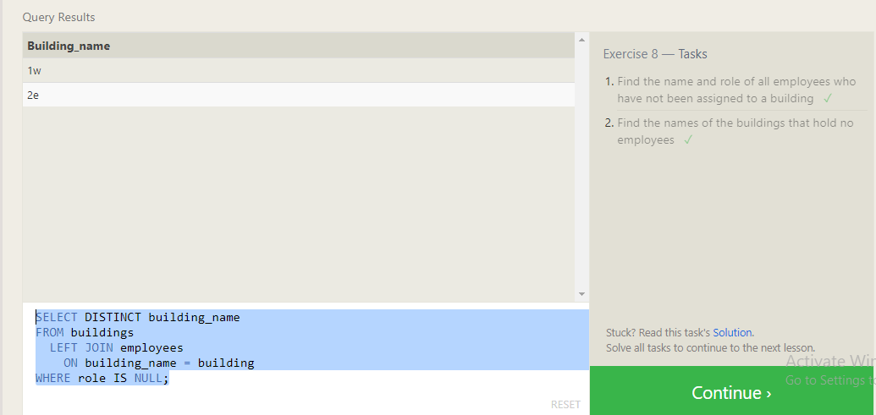

**SQL Lesson 9: Queries with expressions**

1. SELECT title, (domestic_sales + international_sales) / 1000000 AS gross_sales_millions FROM movies JOIN boxoffice ON movies.id = boxoffice.movie_id;
2. SELECT title, rating * 10 AS rating_percent FROM movies JOIN boxoffice ON movies.id = boxoffice.movie_id;
3. SELECT title, year FROM movies WHERE year % 2 = 0;

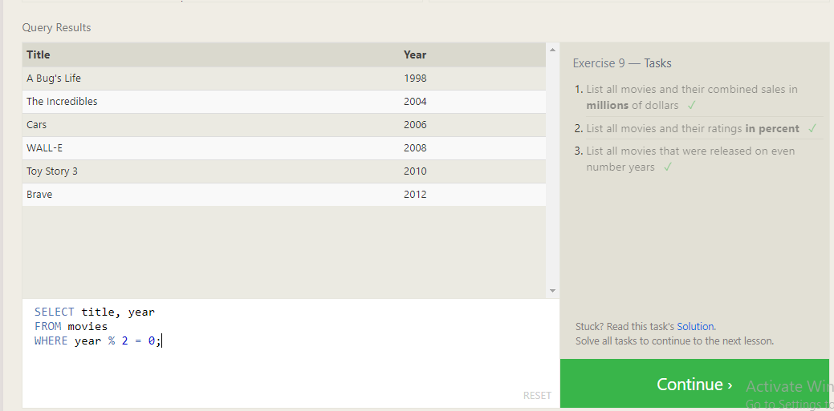

**SQL Lesson 10: Queries with aggregates (Pt. 1)**

1. SELECT MAX(years_employed) as Max_years_employed FROM employees;
2. SELECT role, AVG(years_employed) as Average_years_employed FROM employees GROUP BY role;
3. SELECT building, SUM(years_employed) as Total_years_employed

FROM employees GROUP BY building;

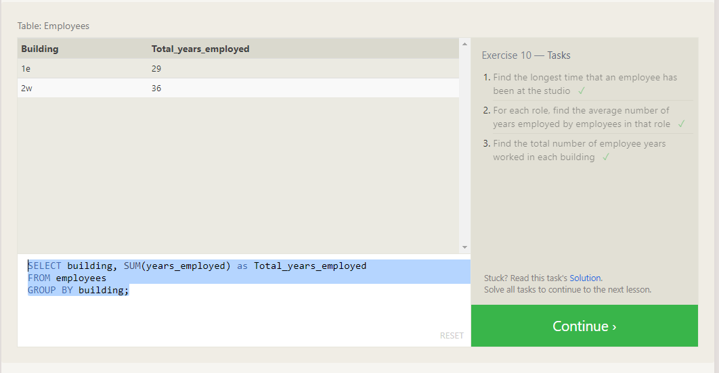

**SQL Lesson 11: Queries with aggregates (Pt. 2)**

1. SELECT role, COUNT(*) as Number_of_artists

FROM employees WHERE role = "Artist";

1. SELECT role, COUNT(*) FROM employees GROUP BY role;
2. SELECT role, SUM(years_employed) FROM employees GROUP BY role HAVING role = "Engineer";

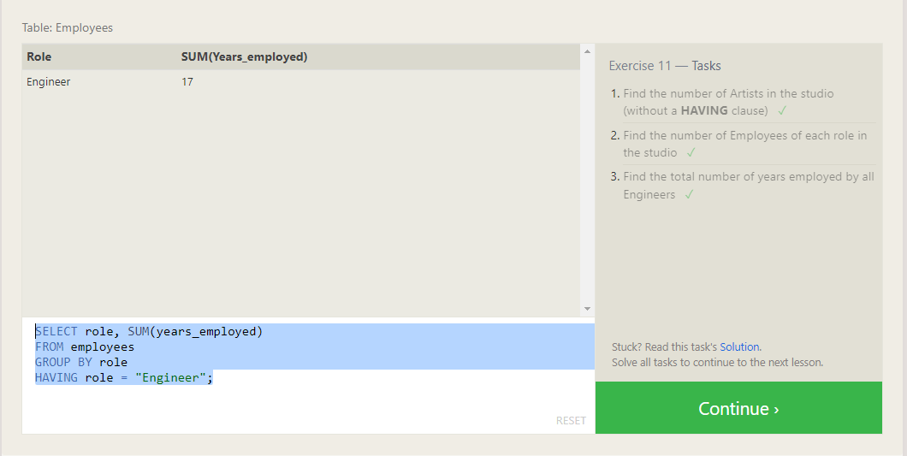

**SQL Lesson 12: Order of execution of a Query**

1. SELECT director, COUNT(id) as Num_movies_directed

FROM movies GROUP BY director;

1. SELECT director, SUM(domestic_sales + international_sales) as Cumulative_sales_from_all_movies FROM movies INNER JOIN boxoffice ON movies.id = boxoffice.movie_id GROUP BY director;

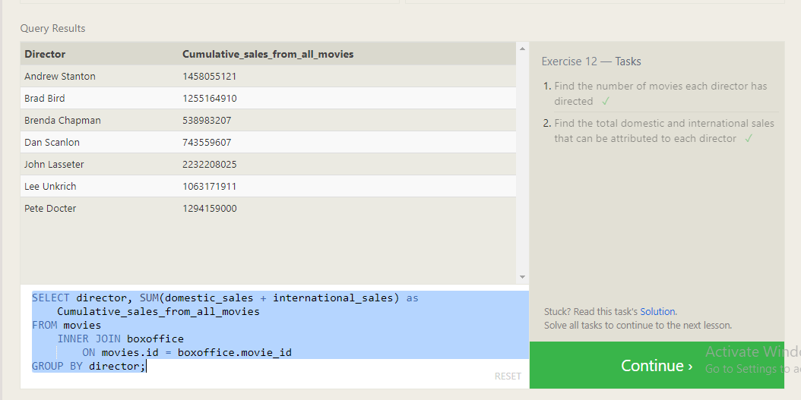

**SQL Lesson 13: Inserting rows**

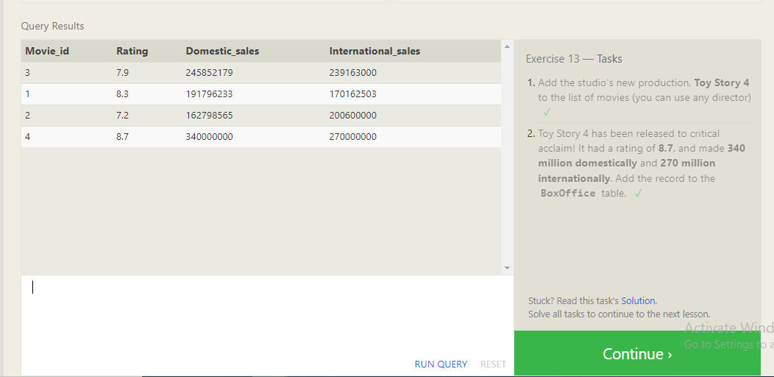

**SQL Lesson 14: Updating rows**

1. UPDATE movies SET director = "John Lasseter" WHERE id = 2;
2. UPDATE movies SET year = 1999 WHERE id = 3;
3. UPDATE movies SET title = "Toy Story 3", director = "Lee Unkrich" WHERE id = 11;

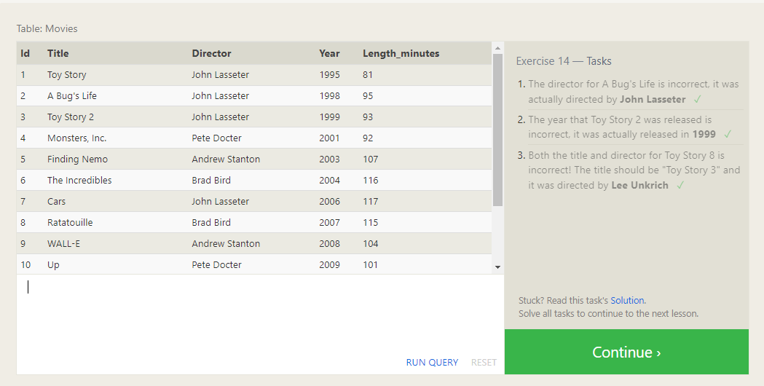

**SQL Lesson 15: Deleting rows**

1. DELETE FROM movies where year < 2005;
2. DELETE FROM movies where director = "Andrew Stanton";

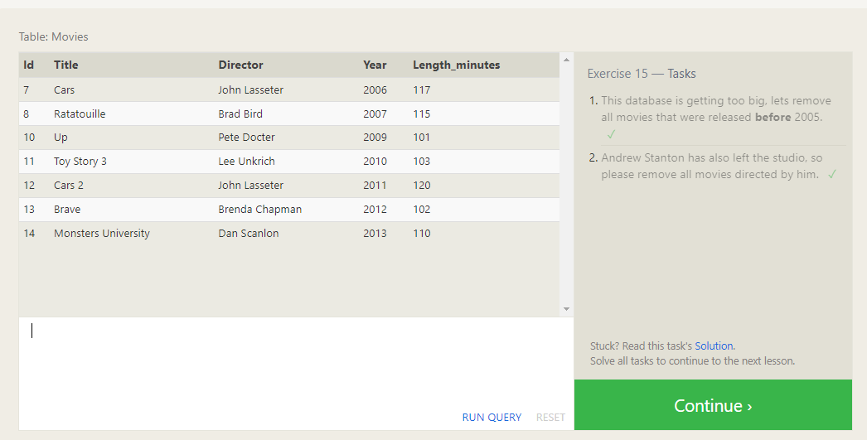

**SQL Lesson 16: Creating tables**

1. CREATE TABLE Database (

Name TEXT,

Version FLOAT,

Download_count INTEGER);

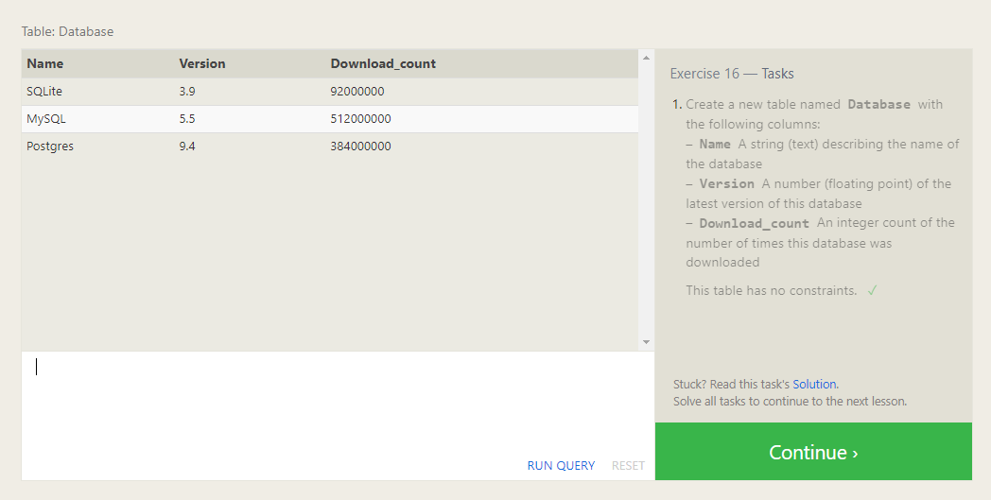

**SQL Lesson 17: Altering tables**

1. ALTER TABLE Movies ADD COLUMN Aspect_ratio FLOAT DEFAULT 2.39;
2. ALTER TABLE Movies ADD COLUMN Language TEXT DEFAULT "English";

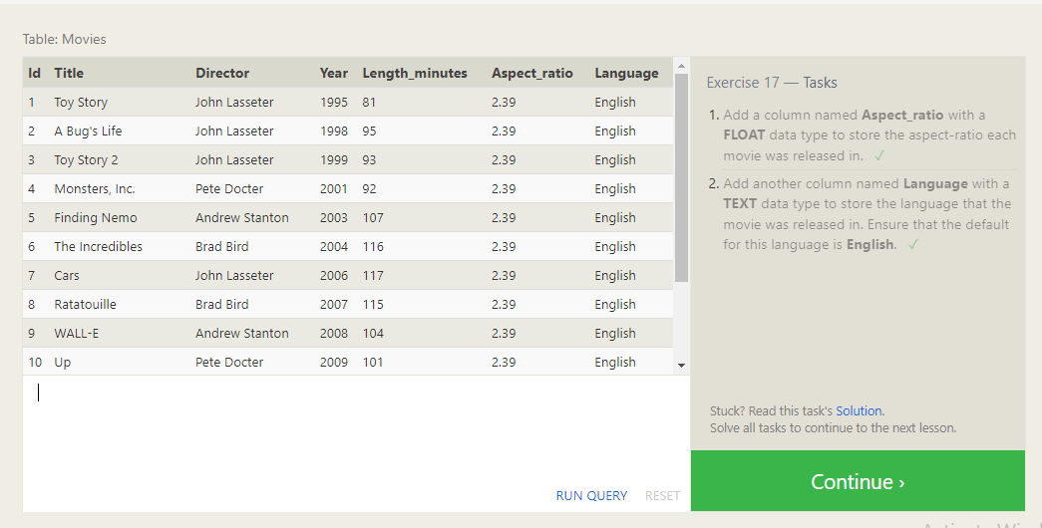

**SQL Lesson 18: Dropping tables**

1. DROP TABLE Movies;
2. DROP TABLE BoxOffice;

